ER DIAGRAM

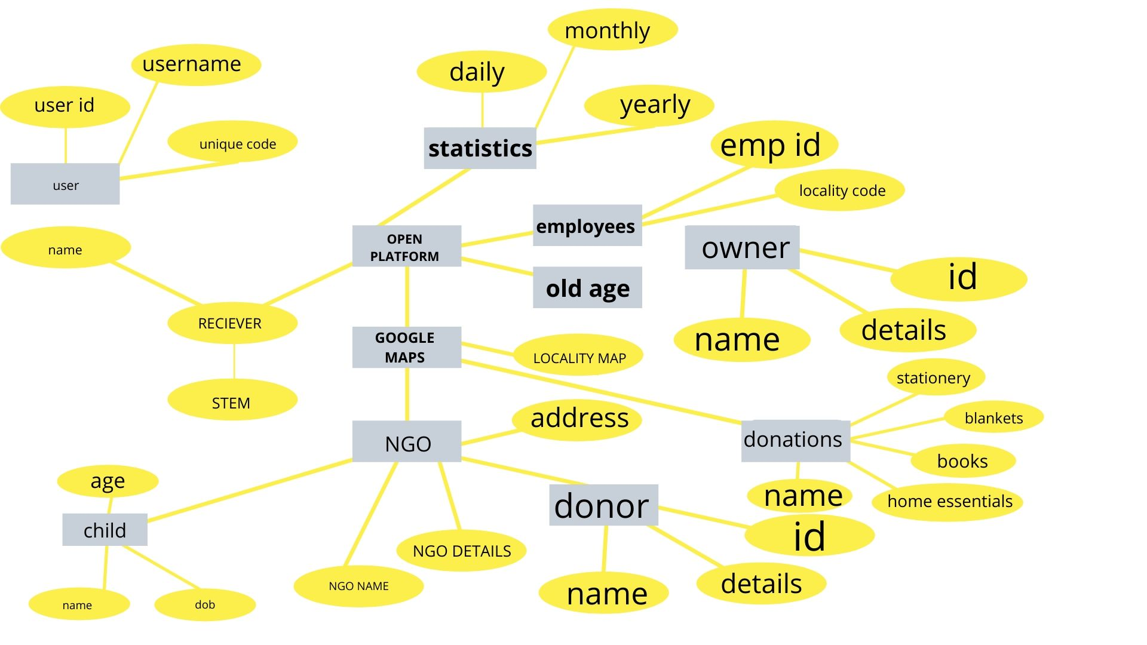

**DATA FLOW DIAGRAM**

**DATA FLOW DIAGRAM**

**DFD-LEVEL0**

Input Output

DFD LEVEL-1

